

Department of Statistics and Data Science
CHRIST (Deemed to be University), Bangalore
Activity Report
Event Type: An Awareness session on Cybercrime
Criteria/Standard Mapping:
Academic  Body | Criteria/ Focus Area  Standard No. | Sub Criteria/  Standard No | Sub-Criteria/  Standard Title
NAAC | 5 | 5.1.3 | Awareness Program
Strategic Plan | 3 | 3.2 | Vibrant and enriching campus experience
Gradguate Attribute |  |  | Societal (Law Abiding)

General Information :

Type of Activity | Awareness Session
Title of the Activity | An Awareness session on Cybercrime
Date/s | 27th February,2026
Time | 12.45PM- 1.45PM
Venue | Room 044, Ground Floor, RnD, Christ (Deemed to be University) Bengaluru- 560029
Collaboration/Sponsor  (if any) | None

Speaker/Guest/Presenter Details :
Name | G. Krishnendu (2441421)
Title/Position | Student of Department of Statistics and Data Science
Organization | Christ University
Title of Presentation | An Awareness session on Cybercrime

Participant’s profile :
Type of Participants | Students and Faculties
No. of Participants | 65

Synopsis of the Activity (Description):
Highlights of the Activity | - Expert-Led Legal Insight: The session was conducted by Dr. Diya C R, Assistant Professor, School of Law, who provided a comprehensive overview of cybercrime from a legal perspective.  - Real-World Cybercrime Cases: The discussion included commonly occurring cyber offences such as phishing attacks, online banking frauds, UPI scams, identity theft, fake job offers, social media hacking, and misuse of OTPs, explained with practical examples.  - Understanding Legal Frameworks: The session highlighted important cyber laws in India, including provisions under the Information Technology Act, and explained the legal remedies available to victims.  - Practical Cyber Safety Measures: Clear guidelines were provided on safe digital practices, recognizing fraudulent links and calls, protecting personal data, and steps to take if one becomes a victim of cybercrime.  - Role of Cyber Security: A clear explanation about the role of cyber security in dealing with cyber crime was discussed by the speaker. The role of digital proof was especially discussed.
Key Objectives/Takeaways | - To create awareness about different types of cybercrimes and their increasing impact on individuals and society.  - To help participants understand the legal implications and rights related to cyber offences.  - To encourage responsible digital behavior and safe online practices.  - To emphasize the importance of not sharing sensitive information such as OTPs, passwords, PINs, or personal details with unknown sources.  - To equip students and faculty with knowledge on preventive measures and reporting mechanisms in case of cyber fraud.

Summary of the Activity | The awareness session on Cybercrime was conducted by Dr. Diya C R, Assistant Professor, School of Law, to educate participants about the growing threats in the digital world and the legal aspects associated with cyber offences. The session focused on common cybercrimes such as phishing, online fraud, UPI scams, identity theft, and misuse of personal information.  Through real-life examples and clear explanations, participants gained a better understanding of cyber laws, preventive measures, and responsible digital behavior. The interactive discussion enhanced awareness and empowered attendees to identify, prevent, and respond effectively to cyber threats, promoting safer and more secure use of digital platforms.
Follow-up Plan, if any | None

Rapporteur Details:
Name of the Rapporteur
Email and Contact No

Event Poster:

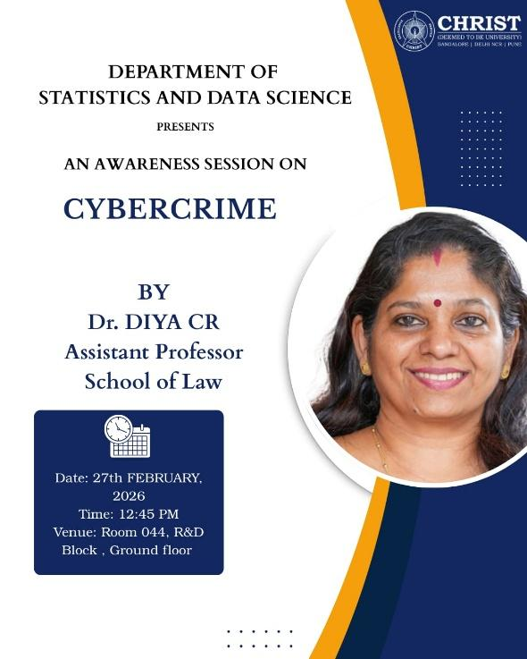

Geo tagged Photos:

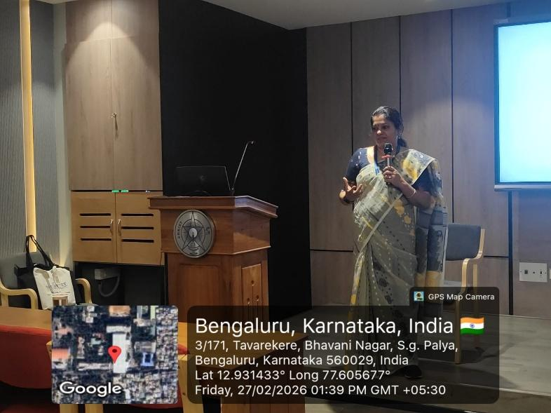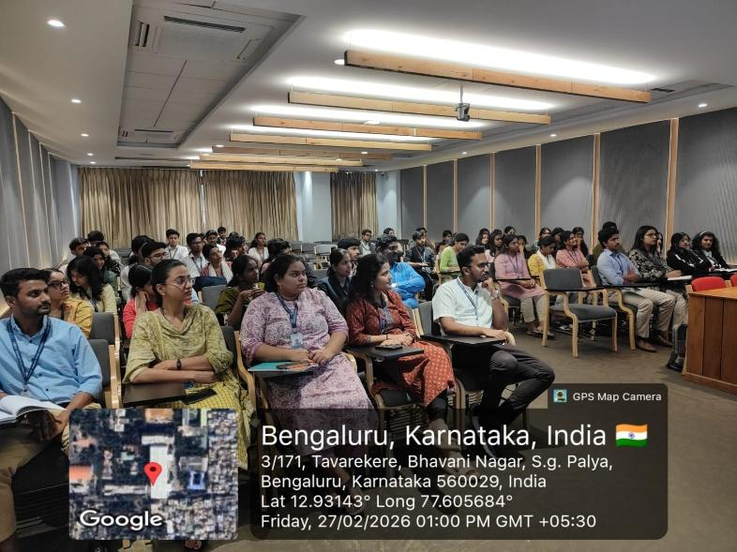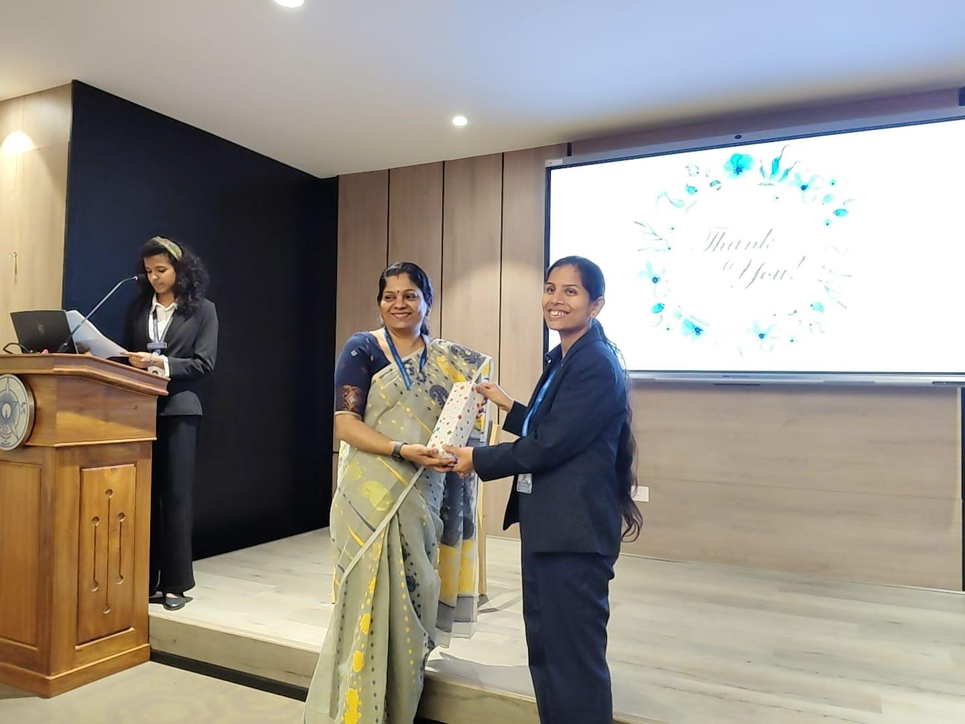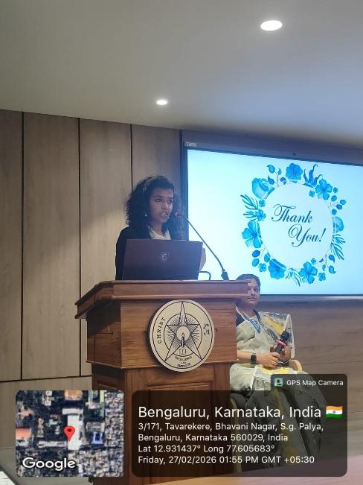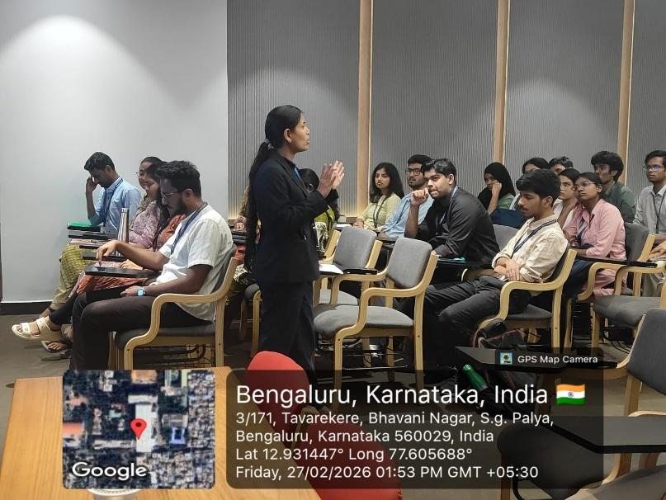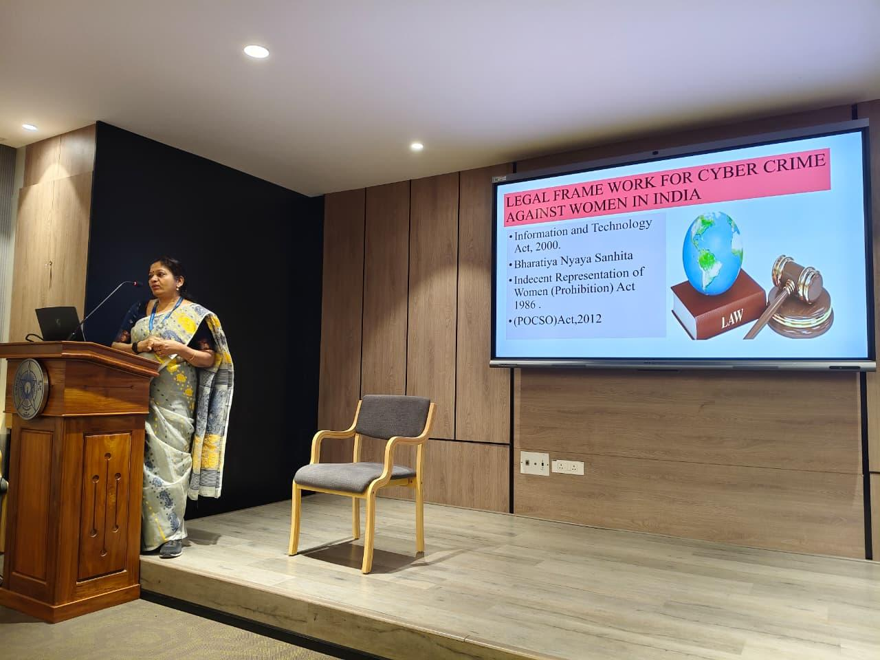

Attendance sheet with signature of participants:

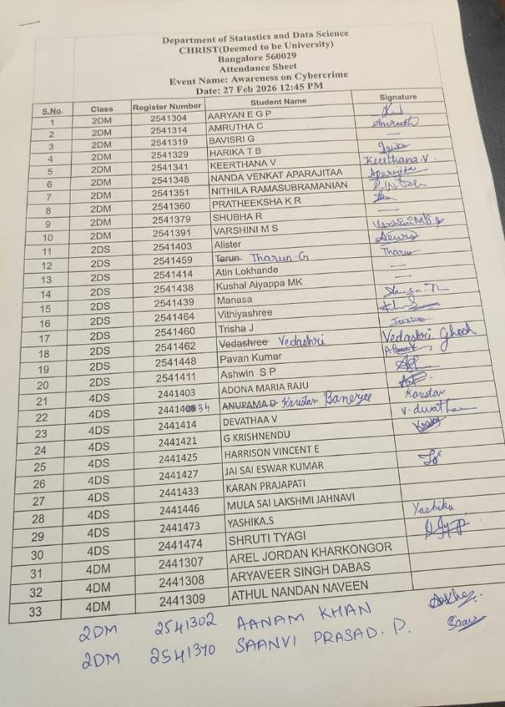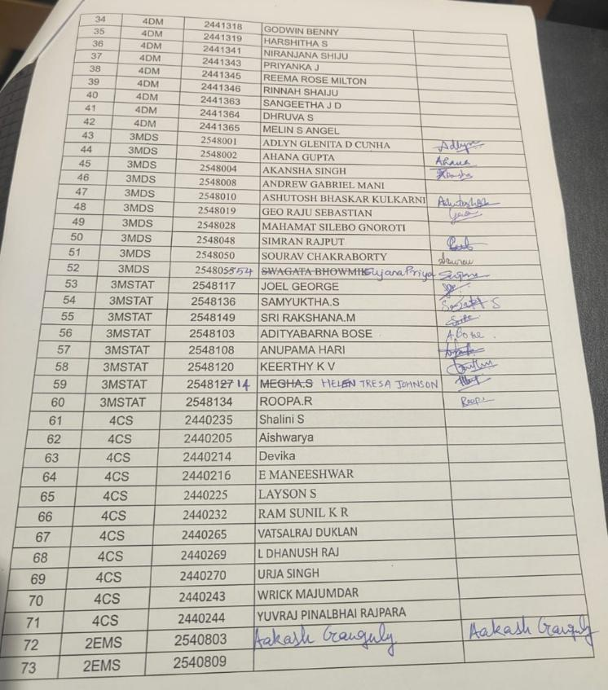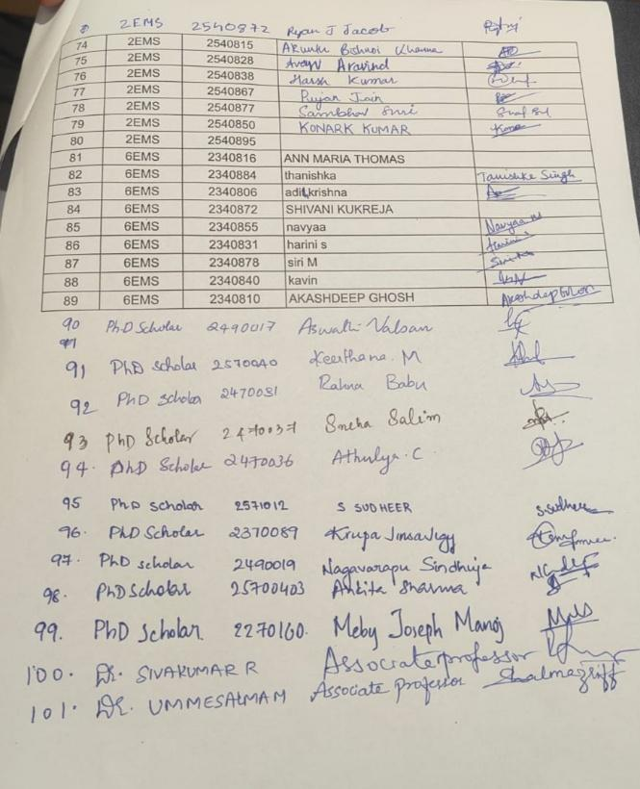

Feedback:

The event successfully created awareness about cybercrime and digital frauds while providing participants with practical knowledge on cyber safety and legal remedies. The session was informative, engaging, and highly relevant in today’s digital age. The live feedback was taken by the students. where the students came forward and appreciated the speakers session. A 10 minutes interaction was further facilitated by the speaker addressing the further queries, providing suggestions to some problems and light on new rules and regulations related to women safety in the digital workplace.

Impact Analysis:

The session significantly enhanced awareness among students and faculty regarding common cyber threats such as phishing, identity theft, UPI scams, and online fraud. Participants gained a clearer understanding of preventive measures, safe digital practices, and the legal framework governing cyber offences.
The program empowered attendees to identify suspicious activities, protect their personal data, and respond responsibly to cyber risks. Additionally, the session strengthened academic engagement by encouraging critical thinking and discussions on contemporary digital challenges.

